

**Pug and Little Paws Boarding**

Pricing per dog

Daycare

Full day: 9am – 6pm £25

Half day: max 4 hrs between 10am – 5pm £15

Full payment is due on day of booking.

Overnight Stays – £25 +

Drop off anytime between 10am – 5pm

Plus on final day of stay:

Collection by 10am No additional charge

Collection by 1pm £10

Collection by 6pm £20

10% of total is due on day of booking and final payment 14 days prior.

Additional Services (to be paid in advance with deposit)

Vet Visits

Within a 5-mile radius only. £10

(Outside of this area your dog will be taken to Medivet Watford, St Albans Rd.)

Occasionally we will allow un-neutered/un-spayed dogs under

Vet advice. Additional costs are incurred due to this for various

reasons including walks in secluded places. Per day £5

Puppies up to a year an additional cost per day. £5

Grooming services

Full Groom £42

Wash & Tidy £32

Wash & Blow dry £22

Nail Clipping £10

Tidy sanitary area £12

Matted hair £12

Total is due on day of booking.

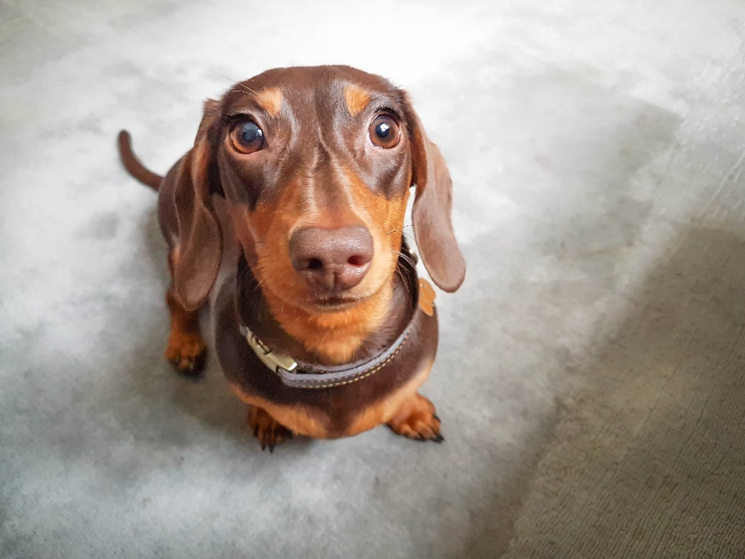

**Payment Options**

* Full payment required 14 days prior to drop off.
* Bank Transfer (preferred)

Name: M Calderbank

Sort Code: 05-05-40

Account No: 34234916

* Cash.

**Please Note:**

Additional £10 on all public holidays except for Christmas period:

Double charges for Christmas Eve, Christmas Day, Boxing Day, New Year’s Eve & New Year’s Day. 25% due on day of booking – non refundable.

**Cancellation:**

Cancellation within 24hrs you will be charged full cost of stay.

Cancellation between 7 days and 24hrs will be charged 50%

10% deposit required at booking (non-refundable) except for day booking which is total cost of day or half day bookings. These may be transferable depending on occupancy and taken within 3 months. Also Bank holidays is 25% of total stay.

**Contact:**

Mobile: 07795364925

Email: calderbank7@aol.co.uk

Address: 7 Mutchetts Close, Watford WD25 9TS

We are fully insured by Pet Business Insurance. Fully qualified first aid for dogs with additional training for brachycephalic breeds. Enhanced DBS.