

**Pug and Little Paws Boarding**

Pricing per dog

Daycare

No daycare will be taken over the weekends Fri – Sun.

Full day: 9am – 6pm £32

Half day: max 4 hrs between 10am – 5pm £22

Full payment is due on day of booking.

(Outside of these times can be negotiated to meet your needs if required on a regular basis.)

Overnight Stays – £42 +

Weekend Stays Fri – Sun

Overnight stays -£52 +

Drop off anytime between 10am – 5pm

Plus on final day of stay:

Collection by 10am No additional charge

Collection by 12pm £15

Collection by 6pm £30

20% of total is due on day of booking and final payment 14 days prior.

Any late collection past the agreed time will be charged at an equivalent of £40 per the hour unless agreed.

Additional Services (to be paid in advance with booking fee)

Vet Visits

Within a 5-mile radius only. £10

(Outside of this area your dog will be taken to Medivet Watford, St Albans Rd.)

Occasionally we will allow un-neutered/un-spayed dogs under

Vet advice. Additional costs are incurred due to this for various

reasons including walks in secluded places. Per day £5

Puppies up to 18 months an additional cost per day. £10

Wedding Chaperone Service POA

Grooming services

Full Groom £42

Wash & Tidy £32

Wash & Blow dry £22

Nail Clipping £10

Tidy sanitary area £12

Matted hair £12

Total is due on day of booking.

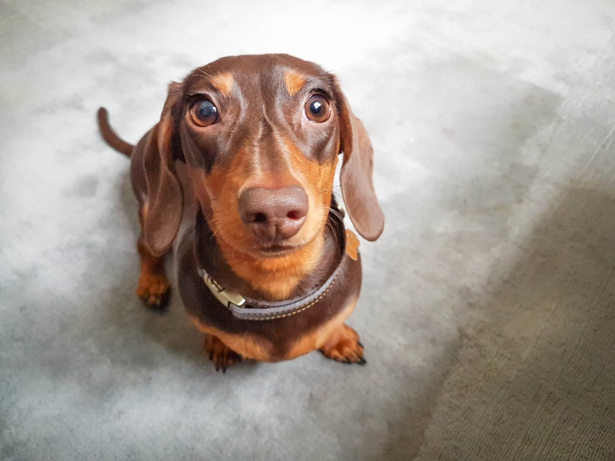

**Payment Options**

* Full payment required 14 days prior to drop off.
* Bank Transfer (preferred)

Name: M Calderbank

Sort Code: 05-05-40

Account No: 34234916

* Cash.

**Please Note:**

Additional £20 on all public holidays except for Christmas period:

Double charges from 24th Dec through to 2nd Jan inclusive. 30% due on day of booking – non refundable.

**Cancellation:**

Cancellation within 72hrs you will be charged full cost of stay.

Cancellation between 14 days and 72hrs will be charged 50%

20% booking fee required at booking (non-refundable) except for day or half day booking which is total cost of day. These may be transferable depending on occupancy and taken within 3 months.

**Contact:**

Mobile: 07795364925

Email: calderbank7@aol.co.uk

Address: 7 Mutchetts Close, Watford WD25 9TS

We are fully insured by Pet Business Insurance. Fully qualified first aid for dogs with additional training for brachycephalic breeds. Enhanced DBS. Fully Licenced TRDC/AALHB70096